

**COURSE SYLLABUS: PLEASE PRINT AND BRING THIS TO EACH CLASS.**

**ENCP6000:**

**CAREER MANAGEMENTFOR ENGINEERS**

**THIS TEXT IS PUBLISHED FOR THE USE OF THE STUDENTS AND FACULTY OF NORTHEASTERN UNIVERSITY. IF IT IS REPRODUCED FOR ANY OTHER PURPOSE, AUTHORIZATION MUST BE OBTAINED FOR THE USE OF MATERIAL CREDITED TO SOURCES OTHER THAN NORTHEASTERN UNIVERSITY. REQUESTS FOR REPRODUCTION PERMISSION SHOULD BE SENT DIRECTLY TO CREDITED SOURCES. THE NORTHEASTERN UNIVERSITY MATERIAL CONTAINED IN THIS TEXT CANNOT BE SOLD.**

**Contents**

Course Policies for ENCP6000: Career Management for Engineers 3

Course Lesson Sequence and Assignments 7

Lesson 1 – Intro to Policies & Procedures, Co-op, Career Goals & Positioning Statements 9

Lesson 2 – Resumes 10

Lesson 3 – Networking and Career Fair Prep 11

Lesson 4 – Engineering Ethics 12

Lesson 5 – Job Searching Tools and Methods & LinkedIn Profiles 13

Lesson 6 – Interviewing 14

Lesson 7 – Mindset, GRIT, and Mindful Learning 15

Lesson 8 – Professional Writing 16

Lesson 9 – Professional Behavior/On the Job Behavior 17

Lesson 10 – Diversity in the Workplace 18

Lesson 11 – Learning Outcomes, Reflections, and Presentations 19

Lesson 12 – Presentation and Course Summary 19

Assignments 20

Appendices 34

## Course Policies for ENCP6000: Career Management for Engineers

1. Welcome to ENCP6000, Career Management for Engineers. During the upcoming term, we believe you will find our work in the course to be interesting, educational, and rewarding. We will meet in accordance with the course schedule (see following pages). Below are the instructors for this course.

|  |  |  |
| --- | --- | --- |
| **Name** | **Email** | **Office** |
| Laura Meyer | l.meyer@northeastern.edu | Dana 515 |
| Maricla Pirozzi | m.pirozzi@northeastern.edu | Dana 512 |
| Laura Adrien | l.adrien@northeastern.edu | Dana 502A |
| Jessica Fisher | j.fisher@northeastern.edu | Dana 514 |
| Carrie Klaphake | c.klaphake@northeastern.edu | Dana 512B |
| Mofei Xu | m.xu@northeastern.edu | Dana 513A |
| Melissa DeGrandis | m.degrandis@northeastern.edu | Dana 513 |

**When contacting your professor or any of the co-op faculty, use your @husky.neu.edu email account **and include your NUID and phone number**. Email from other accounts will be disregarded.

2. In this course you will learn the mechanics of applying for a co-op opportunity at Northeastern as well as critical skills and knowledge to find a position after graduation and to think strategically about your future career. We hope that you will be able to perform a self-assessment in order to maximize the time, opportunities, and resources available at Northeastern so that you can plan and achieve your goals both in class in after graduation.After completing this course, you should be able to:

* Explain and justify the value of cooperative education for you
* Create your own career goals and identify the experiences that you want to have during your cooperative learning experience to further those goals while identifying and evaluating various motivators that drive your decisions
* Articulate your own skills and abilities for a variety of audiences and identify areas for development
* Apply appropriate skills and knowledge to find and obtain a co-op
* Identify standards of ethical behavior
* Plan and be able to document how you will integrate new skills and knowledge learned during co-op in you academic program and articulate your experiences through reflection

3. Employers expect their employees to exhibit professionalism, showing up every day on time, paying attention, and participating. Likewise, you are expected to attend all classes, come on time to class, and participate in class discussions. When at work, you are expected to notify your employer of any absences in advance; so too, you need to coordinate absences with your instructors. Any class missed, for whatever reason, must be made up. To make up a class you will need to write a two-page summary of the material covered in the lesson that you missed (counted in your absences). You must turn in your summary via Blackboard prior to the next class. When you return from an absence, you will be expected to find out what you missed and get back into the rhythm of the class. The class summary provides that opportunity for you. You are responsible for all assignments and material covered in class. To write the summary you should review the slides, check out any resources used (i.e. videos, readings, etc.) and talk with your classmates. Participation and attendance in class is recorded using Poll Everywhere. If you are not there, not logged in, or your device does not work for any reason, you are considered absent and you will need to make up that class. See Blackboard for instructions for setting up an account. Professionalism (attendance, attention and participation) points are awarded per class (60 points total)

|  |  |  |
| --- | --- | --- |
| **Professionalism Status** | **Action** | **Points** |
| Present and attentive in class | None required; you attended class | 5 |
| Missed class | Attend another class if possible  (permission needed from instructors; sign into the class) | 5 |
| Missed class  *Counts as a missed class | Write a Missed Class Summary** OR TBD with instructor | TBD |

*\* Failure to submit even a single “Missed Class Paper” for any class missed during the semester will result in a grade of “Incomplete” for the course.*

*\*\* Missing more than* ***two*** *classes will result in a grade of “Incomplete” for the course.*

4. Grade Plan: The Career Management for Engineers course is a graded course. Your final grade will be based upon the percentage of total points that you earn for assignments and participation. For each assignment in the course, a maximum point value is assigned. See the table below and the course study guide for the value of each assignment. The point value is then converted into a letter grade, A, B, or F. Assignments are graded based on content, writing/presentation, effort, and following instructions. If you receive an F on an assignment, in most cases you will still receive partial credit points based on the quality of your work. Late submissions are not allowed and you will receive a grade of 0 (zero) for that assignment.

5. All work submitted (quizzes, assignments, and missed class summaries) must comply with the university’s [Academic Integrity Policy](http://www.northeastern.edu/osccr/academic-integrity-policy/). Students who submit work that is taken from other sources (other students, on-line resources, templates, published works, etc.) without proper documentation and is not their own work will receive a final grade of zero (0) on the assignment and be reported to the Office of Student Conduct and Conflict Resolution (OSCCR). Northeastern’s policy on academic integrity is below:

**Northeastern University expects students to complete all examinations, tests, papers, creative projects, and assignments of any kind according to the highest ethical standards. Lack of compliance with this policy with eliminate you from any experiential learning opportunity which includes an Internship and/or Co-op.**

The following is a broad overview, but not an all-encompassing definition, of what constitutes a violation of academic integrity.

**Cheating:** The University defines cheating as using or attempting to use unauthorized materials, information, or study aids in any academic exercise. When completing any academic assignment, a student shall rely on his or her mastery of the subject.

Examples include, but are not limited to:

* Unauthorized use of aids such as but not limited to notes, text, the Internet, cell phones, etc. to complete an academic assignment.
* Copying from another student’s academic work.
* Unauthorized communication during an examination. Handing in the same paper for more than one course without explicit permission from the instructor(s). Intentionally viewing a test before it is administered. Storing notes in a portable electronic device for use during an examination.

**Fabrication:** The University defines fabrication as falsification, misrepresentation, or invention of any information, data, or citation in an academic exercise.

Examples include, but are not limited to:

* Inventing data, facts, or sources for an academic assignment. Altering the results of a lab experiment or survey. Citing a source in a bibliography that was not used. Stating an opinion as a scientifically proven fact.

**Plagiarism:** The University defines plagiarism as using as one’s own the words, ideas, data, code, or other original academic material of another without providing proper citation or attribution. Plagiarism can apply to any assignment, either final or drafted copies, and it can occur either accidentally or deliberately. Claiming that one  
has “forgotten” to document ideas or material taken from another source does not exempt one from plagiarizing.

The following sources require citation:

* Word-for-word quotations from a source, including another student’s work.
* Paraphrasing (using the ideas of others in your own words).
* Unusual or controversial facts not widely recognized.
* Audio, video, digital, or live exchanges of ideas, dialogue, or information.
* Students unclear as to whether or not a source requires citation should speak with their professor or consult the Writing Center in 412 Holmes Hall.

**Unauthorized Collaboration:** The University defines unauthorized collaboration as instances when students submit individual academic works that are substantially similar to one another. While several students may have the same source material, any analysis, interpretation, or reporting of data required by an assignment must be each individual’s independent work unless the instructor has explicitly granted permission for group work.

Examples include, but are not limited to:

* Submitting work that closely matches that of another student, even when the work is to be original to the student handing in the assignment.
* Sharing a take-home examination, case write-up, lab report, or any other assignment with a peer without express permission from the instructor.

**Facilitating Academic Dishonesty:** The University defines facilitating academic dishonesty as intentionally or knowingly helping or contributing to the violation of any provision of this policy.

Examples include, but are not limited to:

* Doing academic work for another student.  Making available previously used academic work for another individual who intends to resubmit the work for credit.

**The obligation to Uphold Academic Integrity:**All members of the Northeastern University community have a role in upholding the Academic Integrity Policy. Any member of the community who witnesses a violation of this policy should report it to the appropriate faculty member or the Office of Student Conduct & Conflict Resolution (OSCCR). All instructors are required to refer to Northeastern’s Academic Integrity Policy in their course syllabi.

6. Always remember to wait for a Turnitin receipt after submitting any work to Blackboard. That is your proof of submission.

7. What you get out of this course and how beneficial it is to you will be largely dependent on what you put into it, regardless of whether you get a co-op position or not.

**ENCP6000 Assignments and Point Values**

|  |  |  |
| --- | --- | --- |
| **Assignment** | **Points** | **Grade to Students** |
| Professionalism Score | 60 | A, B or F |
| Positioning Statement | 15 | A, B or F |
| Policy Quiz | 5 | A, B or F |
| Get Informed Module | 10 | A, B or F |
| Career Goals | 15 | A, B or F |
| Interview Attire | 5 | A, B or F |
| LinkedIn Profile | 20 | A, B or F |
| Big Interview | 20 | A, B or F |
| Professional Writing | 25 | A, B or F |
| Resume | 25 | A, B or F |
| Ethics Project | 50 | A, B or F |
| Course Point Total | 250 | Convert to Final Grade per chart |

|  |  |  |
| --- | --- | --- |
| **Grade Scale** |  | **Model** |
| **A     > 225** |  | **Professionalism - 24%** |
| **B    > 200** |  | **Assignments - 76%** |
| **I     < 173** |  |  |

**NOTES**

* Failure to attend out-of-class workshops will result in -5 points.
* Failure to attend at least TWO Speaker Series Sessions will result in -10 points (-5 per session)
  + Speaker Series Sessions dates and locations will be advertised in class.

## Course Lesson Sequence and Assignments

**Spring 2020**

|  |  |  |  |  |  |
| --- | --- | --- | --- | --- | --- |
| **DATE** | | **Lesson** | **TITLE** | **Assignment Due** | |
| **Tues** | **Wed** |  |  |  |
| Jan 14 | Jan 15 | **1** | Introduction: Policies and Procedures  Career Goals/Positioning Statements |  |
| Jan 21 | Jan 22 | **2** | Resumes | Positioning Statement Video  Policies Quiz |
| Jan 28 | Jan 29 | **3** | Career Fair and Networking |  |
| Feb 4 | Feb 5 | **4** | Engineering Ethics | Get Informed Module |
|  |  |  | No Classes – Career Fair Week  Workshops Offered |  |
| Feb 18 | Feb 19 | **5** | Job Search  LinkedIn | Career Goals Story Line |
| Feb 25 | Feb 26 | **6** | Interviewing/Mock Interviews | Interview Attire |
|  |  |  | Spring Break – No Classes |  |
| Mar 10 | Mar 11 | **7** | Mindset, GRIT, and Mindful Learning | LinkedIn |
| Mar 17 | Mar 18 | **8** | Professional Writing | Big Interview |
| Mar 24 | Mar 25 | **9** | Professional Behavior /On the Job Behavior | Writing Assignment: Cover Letter, Email and LinkedIn email |
| Mar 31 | Apr 1 | **10** | Diversity | Resume |
| Apr 7 | Apr 8 | **11** | Learning Outcomes, Reflections, and Presentations | Ethics Presentations |
| Apr 14 | Apr 15 | **12** | Presentations and Course Summary | Ethics Presentations |

|  |  |  |  |  |
| --- | --- | --- | --- | --- |
| **Section** | **Day** | **Time** | **Room** | **Instructor** |
| 01 | Tuesday (T) | 9:50-11:25 | WV H | Xu |
| 02 | Wednesday (W) | 11:45-1:25 | FB 201 | Meyer |
| 05 | Tuesday (T) | 9:50-11:25 | RH 409 | Klaphake |
| 06 | Tuesday (T) | 1:35-3:15 | RY 233 | Pirozzi/Fisher |
| 13 | Wednesday (W) | 11:45-1:25 | WV H | DeGrandis |

FB – Forsyth Building

WVH – West Village H

RH – Robinson Hall

RY – Ryder Hall

**2020-2021 Co-op Basics You Should Know**

* Your co-op must align with the academic calendar at 4, 6, or 8 months in length
* You can participate in co-op during Spring, Spring-Summer, Summer I & II, Summer-Fall, or Fall semesters. Co-op does not extend from Fall-Spring semesters.
* Full-time work is considered to be 35-40 hours per week.
* You must pass ENCP6000, have a GPA of 3.2 or higher (new for Fall 2019), and have passed 16 semester hours in order to be eligible for a co-op.
* You are permitted to go on **ONE** co-op during your program of study.
* You must return to campus after your co-op to complete your program as your co-op cannot be in your last semester.
* Co-ops are neither required nor guaranteed.

|  |  |  |
| --- | --- | --- |
| **Full Summer 2020**  **May 4 - Aug 22**  **\*(*April 26 - Sept 8, 2020* )** | **Fall 2020**  **Sep 8-Dec 19**  ***(August 23-January 10)*** | **Spring 2021**  **Jan 11- May 1**  ***(December 20-May 9)*** |

**Graduate Engineering Co-op Placement Calendar**

**\*Earliest start - Latest end date**

**\*\*If a co-op begins in the Spring semester (January), co-op may end any time before the start of Fall semester.**

**\*\*Additionally, for a co-op that ENDS in the Fall (December), you may start anytime in the Summer.**

**\*\*If you are doing a Summer ONLY co-op, it must be for the entire 4-month length.**

## Lesson 1 – Intro to Policies & Procedures, Co-op, Career Goals & Positioning Statements

**Learning Objectives**:

1. Learn what cooperative education is
2. Understand course policies and requirements
3. Learn co-op rules and eligibility requirements
4. Work on developing short and long term career goals
5. Create your Positioning Statement

**Before Class**:

1. Read the Announcements on Blackboard and complete all tasks listed under: **Preparation BEFORE Your First Class** (videos, Resumes).
2. Read and download the Syllabus (on Blackboard→Syllabus).
3. Read Graduate School of Engineering Cooperative Education Program Eligibility Requirements and Guidelines.<http://www.coe.neu.edu/graduate-co-op/graduate-co-op-eligibility-and-requirements>
4. Create a [Poll Everywhere](https://www.northeastern.edu/ats/students-logging-into-poll-everywhere/#_ga=2.161022330.650209049.1565030301-308985461.1501239844) account.

**Homework (see Blackboard for due dates/times)**:

1. To prepare for Quiz #1:
   1. Read and be able to explain the university academic integrity policy <http://www.northeastern.edu/osccr/academic-integrity-policy/>
   2. Review the Course Policies.
   3. Review Co-op Eligibility Requirements
2. Complete the Blackboard Policies Quiz.
3. Submit your Positioning Statement video on Blackboard

## Lesson 2 – Resumes

**Learning Objectives:**

1. Write your resume

**Before Class**:

1. Complete the homework assignments (from the previous class).
2. Read the Employer Engagement and Career Design webpage on resumes:
   1. [https://careers.northeastern.edu/article/resumes/](https://nam05.safelinks.protection.outlook.com/?url=https%3A%2F%2Fcareers.northeastern.edu%2Farticle%2Fresumes%2F&data=02%7C01%7Cl.meyer%40northeastern.edu%7Ca7e1733d2a474e07920a08d71c49e388%7Ca8eec281aaa34daeac9b9a398b9215e7%7C0%7C0%7C637008975990279593&sdata=%2Fa38jDIVX1%2FktO5eZ7Ddk%2BEhu6GZ2SStnVivSEPDP9Q%3D&reserved=0)
   2. [https://careers.northeastern.edu/app/uploads/2018/11/Resume-Guide-6.15.2018.pdf](https://nam05.safelinks.protection.outlook.com/?url=https%3A%2F%2Fcareers.northeastern.edu%2Fapp%2Fuploads%2F2018%2F11%2FResume-Guide-6.15.2018.pdf&data=02%7C01%7Cl.meyer%40northeastern.edu%7Ca7e1733d2a474e07920a08d71c49e388%7Ca8eec281aaa34daeac9b9a398b9215e7%7C0%7C0%7C637008975990279593&sdata=OPUsvCFRiXGTNkAzNL%2FgSGb0bZDxp4SVInRGKsP2tHY%3D&reserved=0)

**Homework (refer to the Syllabus and Blackboard for due dates/times)**:

1. Get Informed Module

## Lesson 3 – Networking and Career Fair Prep

**Learning Objectives**:

1. Discuss and explore the various ways to network
2. Understand the most effective way to network and how to execute it properly
3. Be Prepared for the Career Fair
4. Construct a plan to maximize your results at the Career Fair

**Before Class**:

1. Watch: “Graduate student resumes: highlighting an academic project” video <https://www.youtube.com/watch?v=06sSWmWG3TM>

**Homework (refer to the Syllabus and Blackboard for due dates/times)**:

1. Complete the **Get Informed Module**. You’ll find the module in Blackboard on the left hand side.
2. Prepare for class in two weeks by downloading (and printing if you wish) and reading the ENCP6000 Ethical Case Studies found on Blackboard→Course Material→Engineering Ethics→ENCP6000 Ethics Cases and bring the Case Studies that corresponds to your group number with you to class. You will be doing an in-class project!

**Notes**:

Career Fair Preparation:

1. The career fair will be held on Thursday, February 13, 2020
2. Update your professional resume.
3. Practice your Positioning Statement aloud.
4. Visit the Employer Engagement and Career Design website for career fair info:
   1. Use the information there to start your research efforts and sharpen your skills for attending the Career Fair. You can also check the Employer Engagement and Career Design website to get a list of employers who will be there and check for jobs and companies you might be interested in. There are also workshops available to help you maximize your time there. Links to these resources can be found on Blackboard.
   2. Visit the Employer Engagement and Career Design Center [https://careers.northeastern.edu/article/the-career-studio/](https://nam05.safelinks.protection.outlook.com/?url=https%3A%2F%2Fcareers.northeastern.edu%2Farticle%2Fthe-career-studio%2F&data=02%7C01%7Cl.meyer%40northeastern.edu%7Ca7e1733d2a474e07920a08d71c49e388%7Ca8eec281aaa34daeac9b9a398b9215e7%7C0%7C0%7C637008975990289590&sdata=%2BiHLKUnHwCuM8h%2BPB4tnCsoNJEN%2BVhmVOS%2FNlBM4d%2Bg%3D&reserved=0)

## Lesson 4 – Engineering Ethics

**Learning Objectives**:

1. Become familiar with the key tenants of the National Society of Professional Engineers (NSPE) Code of Ethics.
2. Be able to explain ethical expectations in the US workplace.
3. Analyze and evaluate a situation in terms of ethical considerations.
4. Articulate the importance of ethical behavior in engineering.

**Before Class**:

1. Read the Engineering Code of Ethics found on Blackboard under Course Material/Engineering Ethics.
2. Also, download (and print if you choose) and read the ENCP6000 Ethical Case Studies found on Blackboard→Course Material→Engineering Ethics→ENCP6000 Ethics Cases. We will be working with these cases in class.

**Homework (refer to the Syllabus and Blackboard for due dates/times)**:

1. Submit your Career Goals Story Line to Blackboard.
2. Begin preparing for your capstone project on an ethical dilemma in engineering. Instructions are below.

## Lesson 5 – Job Searching Tools and Methods & LinkedIn Profiles

**Learning Objectives**:

1. Explain utilization of NUcareers to search, apply for jobs, & upload documents
2. Conduct an effective job search using career fairs, online tools, networks, and career design
3. Learn where, why, and how to apply for jobs
4. Create a LinkedIn profile that conforms to professional standards
5. Explain how you can use LinkedIn features (groups, connections, job postings) to further your career
6. Compose messages for various types of professionals

**Before Class**:

1. Complete your homework (Career Goals Story Line)

**Homework (refer to the Syllabus and Blackboard for due dates/times)**:

1. Come to next class dressed for an interview (graded assignment).

## Lesson 6 – Interviewing

**Learning Objectives**:

1. Identify the different types of interviews and articulate their purposes and differences.
2. Prepare for and carry out an interview in accordance with professional standards.

**Before Class:**

1. Complete the homework.
2. Read the following: <http://media.myjobhelper.com/img/what-to-wear-to-your-job-interview.jpg?_ga=1.60356589.1771096765.1483573911>
3. Read How To: Dress For Interview Success at <http://www.resolution-tech.com/interview-dress/>

**Homework (refer to the Syllabus and Blackboard for due dates/times)**:

1. Complete and submit your LinkedIn Profile in Blackboard.

## 

## Lesson 7 – Mindset, GRIT, and Mindful Learning

**Learning Objectives**:

1. Distinguish between a growth and fixed mindset
2. Discuss the relationship between a growth mindset and your approach to success, failure and effort
3. Understand GRIT and the role effort plays in GRIT
4. Explain what mindful learning is and its effect on your work and studies

**Before Class**:

1. Complete the homework.
2. Make sure you have downloaded and/or printed the Mindset Quiz.
3. Read chapters 3 & 6 in *Mindful Learning* as well as the article, “Mindfulness in the Age of Complexity”, found on Blackboard →Course Material →Mindset, Mindful Learning and Motivation.

**Homework (refer to the Syllabus and Blackboard for due dates/times)**:

1. Complete and submit your Big Interview assignment

## Lesson 8 – Professional Writing

**Learning Objectives**:

1. Be familiar with the different types of professional writing within the job search process
2. Review templates and examples of professional writing
3. Be able to write professionally with confidence

**Before Class**:

1. Complete your homework.

**Homework (refer to the Syllabus and Blackboard for due dates/times)**:

1. Find a job posting that interests you and write a **cover letter** for that job.
2. Submit the job posting **AND** cover letter on Blackboard. Make sure you receive confirmation from Blackboard that it was successfully submitted. In the Assignments section of the syllabus are directions for this assignment and a sample job posting and a sample cover letter for you to use as a guide.
3. Respond to a recruiter via an email.
4. Write an email via LinkedIn

## Lesson 9 – Professional Behavior/On the Job Behavior

**Learning Objectives**:

1. Understand and demonstrate the professional behavior expected by MGEN and the COE
2. Explain and exhibit the professional behavior expected in the US workplace
3. Feel confident in your own ability to make decisions and take actions

**Before Class**:

1. Complete the homework.
2. Watch the video <https://youtu.be/14bCsM16bYo>

**Homework (refer to the Syllabus and Blackboard for due dates/times)**:

1. Revise on your resume and submit it on Blackboard.

## Lesson 10 – Diversity in the Workplace

**Learning Objectives:**

1. Learn about the diverse forms of identity and how they can be encountered in the workplace
2. Identify ways to achieve career goals through one’s identity
3. Review of Title IX policies and rights
4. Be able to respond professionally to potentially reportable workplace situations

**Before Class:**

1. Complete the homework.

**Homework**:

1. You should be working on your Ethics project as we will begin presentation in two weeks!

## Lesson 11 – Learning Outcomes, Reflections, Course Summary, and Presentations

**Learning Objectives**:

1. Learn how outcomes specify what you will know or be able to do as a result of a **learning** activity
2. Describe what you’re expected to know and be able to do; relate to your skills, knowledge, and behaviors you’ll acquire
3. Understand what Reflections are in relation to your co-op experience

**Before Class**:

1. Submit your Ethics Presentation in Blackboard

**During Class:**

1. Presentations

**Assignments**

**POSITIONING STATEMENT**

**Due**: **9/18 at 9:00 a.m. EST**

A positioning statement is a personal statement about you. It should include what is special about you so that you can capture the interest of the person you are addressing. Think about the following:

* What are some strengths of yours?
* What are some accomplishments you have made?
* How do your strengths, experience, background and accomplishments contribute to your career direction?
* Why do you think what you learned will help you succeed at your next job or the company you are applying to?

**Assignment Instructions:**

* Write a positioning statement that describes **YOU** in terms of your experience, expertise, and unique skills and strengths.
* Practice speaking your statement aloud. Time yourself, and make sure you are not speaking for more than 60-90 seconds long. Ask yourself the following:
* Am I talking too fast?
* Am I talking for too long?
* Is my message clear?
* Do I look nervous? How is my body language?
* Record a video of yourself speaking your positioning statement. Pretend you are talking to a potential employer. While you do not need to wear formal work attire, you should be business casual.
* Do NOT read or recite the statement verbatim!
* **BONUS (+2 points):** Look at the list of companies who are attending the career fair. Select a company as your “target company.” Researched this target company. As a last sentence either mention something you are interested in at the company or ask what types of opportunities may become available that fit your skills and interests.
* Submit your video on Blackboard. Make sure you receive a digital receipt from Turnitin confirming that it was successfully submitted.

You may or may not choose to use a template like the one below. Be creative!

**Positioning Statement Template:**

My name is         and I am a           . For the past     years, I have been                       .  I have strong skills in            . While I was at                    , I ____________ (describe one or 2 strengths and accomplishments.)  Finally, would you please provide some ______________ (feedback, information, insight, etc.) regarding any positions, jobs, co-ops within your organization.

**Career Goals Story Line Assignment**

**Due: 10/16 at 9:00 a.m. EST**

If you don’t know where you want to go, it is hard to get there! To develop your career goals, first think about your ultimate long-term goal. Then think about a well-defined logical path that will help you to achieve that goal. The path should include your short term goals (co-op position and first job after graduation) and your intermediate goals (5-10 years after graduation). Consider how each position prepares you for the next and advances your career goals. Ultimately, your career goals are driven by a wish to achieve purpose – combining that which you love, that which you are good at, that which you can be paid for, and that which the world needs. Remember the diagram from class.

**Instructions for the Assignment:**

Draw a diagram showing your career path and include the information below (Section 1 & 2). You must submit your assignment though Blackboard (make sure you receive a digital receipt from Turnitin confirming that it was successfully submitted). Make sure you have scaled it appropriately, so all content is visible. Your story board timeline will be assessed on how well you addressed the following components:

* Awareness of industry trends
* Following directions
* Creativity of design (Relevant & Distinguishable)
* For the Heading: ENCP 6000, Section X Career Goals Story Line Last Name, First Name

Include:

**Section 1: Educational Background & Previous Professional Experience**

* Write the university name, program of study, location, and dates of your undergraduate degree
* If you have any professional experience prior to beginning your graduate degree, write the company name, job title, employment dates
* Add technical skills you acquired and your proficiency level (beginner, intermediate, advance)
* Write the name of your current degree program at Northeastern University
* Indicate with dates significant events that impacted where you are today

**Section 2: Co-op Position / First Job**

* Write your ideal co-op/first job title. What type of company would you like to work for (i.e., describe the products or services the company provides)? Is the company well-established (i.e., Fortune 500, start-up venture, or something in between)?
* Write the skills, knowledge and abilities required to do that job. BE SPECIFIC!!! Consider the type of position you hope to get after graduating from Northeastern.

(Hint: Look at a similar job description on LinkedIn or Indeed.com. What types of skills, knowledge or abilities do you need to acquire to make you a more distinguishable candidate for this position after you graduate from Northeastern?)

**Section 3: Intermediate Career Goal: Position 5-10 years into your Professional Career**

* Write what you want your title or role to be? What type of company would you like to work for (i.e., describe the products or services the company provides)? Is the company well-established (i.e., Fortune 500, start-up venture, or something in between)?
* Write the skills, knowledge and abilities required to do that job 5-10 years after graduate school. BE SPECIFIC! These might be more of soft skills or personable attributes if you’re looking to be promoted to management.

**Section 4: Ultimate Career Goal**

* Write your ultimate professional goal (i.e. I would like to create my own software development business or I would like to become the CIO of a software application company). Include the position/title and the year you’d like it to happen.
* Include the words that would describe the company culture. Is it a service or a product?
* Write where you would like to work (i.e. United States, India, China, Canada, UK, etc.)

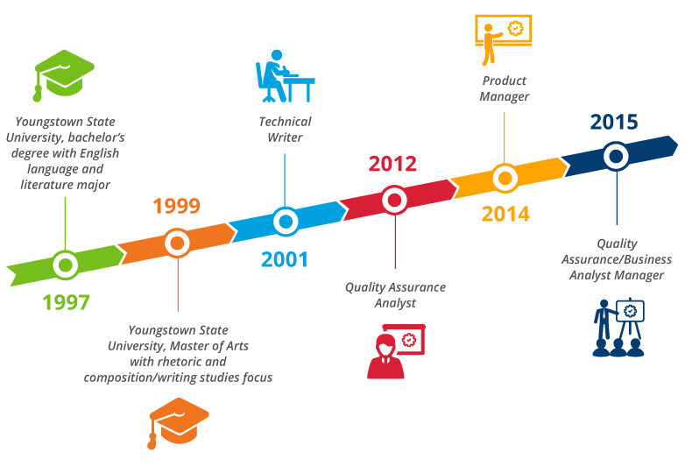

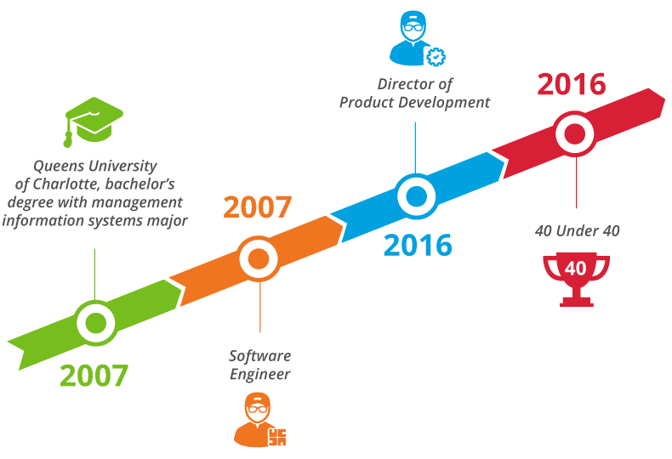

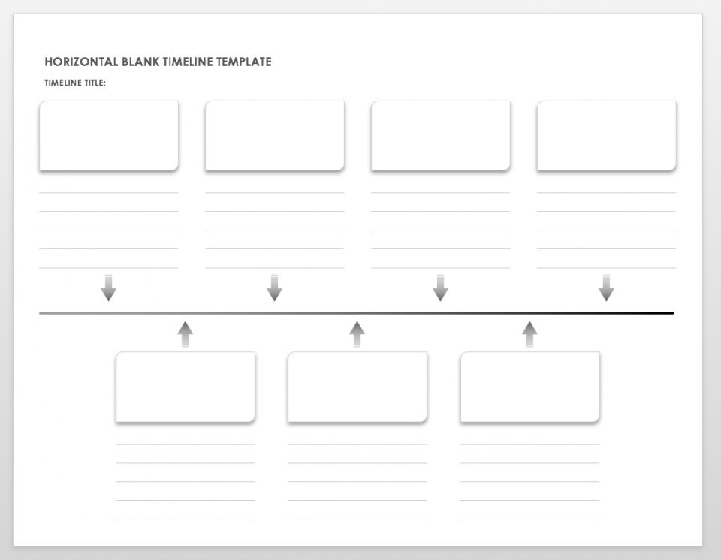

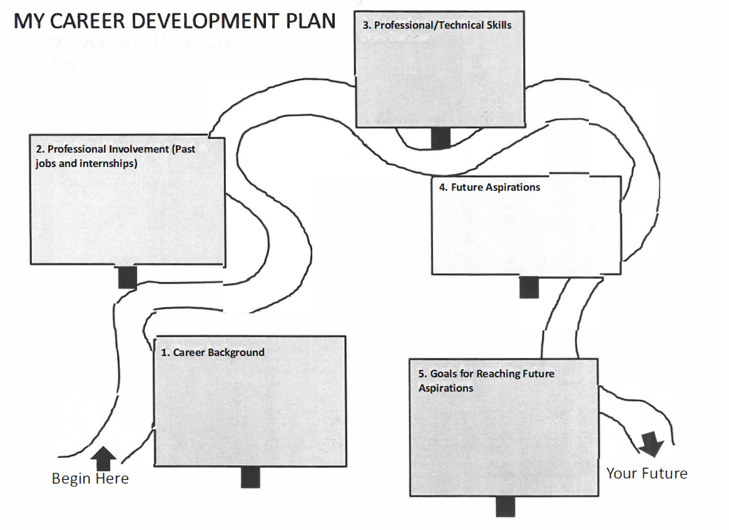

#### LinkedIn Profile

#### Due: 10/30 at 9:00 a.m. EST

Create or update your LinkedIn profile using the guidelines discussed in class. You must include a professional picture, headline, clear career progression, connections, groups and endorsements. You must join at least three technical groups and follow at least three companies, not schools. Everything must be in English with U.S. formatting.

Your LinkedIn Profile will be assessed on the following components:

* Professional picture: High-quality resolution, interview attire, headshot, neutral background (no distractions!)
* Headline: Personalized to student – distinguishable! (not: “MS student seeking co-op”). **NOTE: You will lose points for “seeking co –op”!**
* Summary: Well-written narrative, no grammatical errors/typos, includes applicable skills/keywords – distinguishable!
* Experience: Well-written accomplishment statements (with action verbs), reverse chronological order, includes company location and project context (if applicable)
* Education: Reverse chronological order, schools and correct degree (Master of Science in )
* Groups: Join at least three technical career related groups (Java Developers, Supply Chain Geeks, etc. You should also join Northeastern University Graduate School of Engineering Co-op)
* Companies: Follow at least three companies (not including Northeastern University or any other school)
* Endorsements: You need at least three endorsements. They can be in one skill or 3 skills

When grading the assignment, if we cannot see your picture, you will fail the assignment. Make sure you have your profile set so all can see. Never include personal information such as your home address, birth year, marital status or schooling prior to undergrad. Additionally, if you have characters other than English, you will fail the assignment. Your profile will be viewed and graded after the due date.

You may include a link to your profile on your resume.

**BIG INTERVIEW**

**Due**: **11/6 at 9:00 a.m. EST**

Complete ONE Big Interview Assignment based upon your technical function area of interest. To access Big Interview, follow this link: <https://neu.biginterview.com/> or search “Big Interview” in your MyNortheastern portal. Once you’ve logged in, click on assignments on the top navigation bar. Enter the respective assignment code which can be found on the announcement section of Blackboard.

Each of the assignments have the same amount of questions and were strategically created based upon the top job areas students pursue. You must answer each question and submit by the scheduled due date and time.

[HOT TIP:] In a real interview situation, answering these questions is what gives you the opportunity to differentiate yourself from others and become the candidate selected for the job offer. How do you win the interview? With Preparation and Practice!

**Professional Writing Assignments**

**Due**: **11/13 at 9:00 a.m. EST**

#### *Please upload all three of these assignments into Blackboard as one file*

#### Assignment 1: Cover Letter

* The purpose of a cover letter is to summarize the person’s relevant experience, to express interest in the position, and to demonstrate writing ability.
* You will locate a job to which you want to apply. Then research the company and then create a cover letter for that job. Note: Both the job description you use and the cover letter must be submitted for this assignment.

**Format**

* Follow standard business letter format. The only exception to this is the heading section with your address, which can be a bit more stylized and feature your name if you would like.
* Don’t forget your email and phone, the date, the addressee’s name, and the addressee’s address. Your cover letter header should look like your resume header.
* Use 11 or 12-pt, professional font and block formatting, and stay to one page.
* Write “Enclosure” at the bottom to signify that your resume is included.

**The Greeting**

* It’s important to research who will be reading your letter and address your letter to that person specifically.
* Also, remember to use Ms. instead of Miss. or Mrs., and if you are unsure of the person’s gender, just list the first and last name (e.g. “Dear Taylor Benson:”).
* Include a colon in your greeting instead of a comma for this formal occasion.

**The Body**

* Your first paragraph should clearly state the job title you are applying for. Traditional cover letters explain why you are writing and how you found out about the job (e.g. a job ad, a job fair meeting, or the suggestion of someone you both know). The new generation of cover letters often begin by stating a need of the employer’s (following up with how you will meet it), promising a benefit to the reader, or referring to a recent piece of relevant news for the field/company.

**The Final Paragraph**

* Should invite them to interview/contact you and offer a method of reaching you (phone, email…), or tell them you will be calling them by a certain time (usually a week). This is also place to give them any important details about next steps (if you will be in town and available to meet at a certain time, if they should use your home phone instead of work, etc).
* Remember to thank them for considering your application or find another way to end on a note of goodwill. The Closing Include a valediction, and this should probably be formal (e.g. “Sincerely” or “Cordially” rather than “Thanks”).

#### *On the next two pages are a sample job description with a sample cover letter. Both the job description and cover letter must be submitted for this assignment. You must copy and paste the entire job description into your Word doc, not the link only.*

**TripAdvisor Vacation Rentals Software Engineering Co-op**

TripAdvisor, the market leader in travel research, is seeking a talented Software Engineer Co-op for the Vacation Rentals team in its Boston office at North Station.

The Vacation Rentals team, a separate business unit within TripAdvisor, is building the next big product - making it easy for our customers to research and book vacation rental.

As a Software Engineering co-op, your work will encompass the key areas of execution for the Vacation Rentals business including building APIs, micro-services, web UIs, native apps, all on a PCI compliant platform. We move quickly, projects are short (in average 3 days), and you will ship features every day used by millions of people.

TripAdvisor is well known for having an extremely strong engineering organization; you will be working with the best and getting stuff done, in the fastest growing area of an incredibly profitable, growing, fun company.

**Qualifications**

* Working towards a BS or MS in Computer Science or equivalent
* Be available for co-op January 2017- June 2017
* You have a solid foundation in data structures, OO Design with rock-solid programming skills
* You have some hands-on knowledge of Linux, Java, JavaScript and related open source technologies such as Apache, Tomcat, and MySQL
* You have strong interpersonal skills, analytical skills, combined with intellectual curiosity. A desire and ability to "get things done" are essential requirements
* You want to work in a rapidly changing, collaborative, and iterative product development environment

See the sample Cover Letter below. Use it as a guide for what your Cover Letter needs to include for this assignment.

**Sachin Shah**

Your heading should match your resume heading

123 Street, City, ST 02468

[myname@husky.neu.edu](mailto:myname@husky.neu.edu%20) | 617-123-4567

The inside address should include the name, title and business of the company. If you know the name of the recruiter or HR individual, include it here.

The body should contain your purpose, why you are qualified and your contact information

Hiring Manager

Human Relations Department TripAdvisor LLC

400 First Ave

Needham, MA 02494

Use last name only in the greeting, also called a salutation, or title if name isn’t known.

Dear Hiring Manager:

I am writing to express my interest and apply for your job listing for a Software Engineer Co-op, which I found on Northeastern’s Co-op network. I am a diligent, self-motivated and analytical computer systems engineering graduate student at Northeastern University. I enjoy being challenged and working on projects that require me to work outside my comfort zone and knowledge set, while continuing to learn new languages and develop techniques that are important to gain more practical experience and add to the success of an organization.

As a computer systems engineer, My technical expertise includes cross-platform proficiency (Windows, Linux), strong foundation in programming languages (including C, C++, C#, Java, and SQL); and advanced knowledge of developer applications, tools, methodologies and best practices (including OOD, web-development using open source technologies like Apache Tomcat, Spring MVC) and engineering big-data systems. I have a strong interest in information technology and business applications. The professional experience as a mainframe developer at Accenture for one year, helped me explore the domain of the use of technology to attain business goals. As a proactive and enthusiastic developer, my tasks included analyzing functional business requirements and managing all facets of product development lifecycle which includes developing of COBOL/DB2 applications using JCLs/PROCs. My active listening skills helped in handling problems and taking improvement advice. I have been repeatedly recognized for developing innovative solutions and have received appreciation for proving credible work which resulted in leading heights of achieving targets.

TripAdvisor is well known for having an extremely strong engineering organization who believes working with the best and valuing perfection. This is what excites me about working at TripAdvisor. I have excellent time management skills that help me to define priorities and implement activities tailored to meet deadlines. I am eager to face the challenges to develop creative and innovative systems solution for TripAdvisor.

I look forward discussing about this opportunity further with you. You can contact me at 617-878-1234 or [shah.s@husky.neu.edu.](mailto:%20shah.s@husky.neu.edu.) Thank you for your time and consideration.

Include a closing.

Sincerely,

Include a space for your signature before your typed name.

Sachin Shah

Enclosure

**Assignment 2**: **How to Ask for an Informational Interview**

Based upon what you learned in Lesson 3 about networking, draft an email to an alumni or current co-op that you know asking for a 20 minute informational interview. The link below is a helpful website to give you some templates that you can use to formulate your email:

[https://careers.northeastern.edu/article/informational-interviewing/](https://nam05.safelinks.protection.outlook.com/?url=https%3A%2F%2Fcareers.northeastern.edu%2Farticle%2Finformational-interviewing%2F&data=02%7C01%7Cl.meyer%40northeastern.edu%7Cb12c3db771e44f2ea0b208d720f857d1%7Ca8eec281aaa34daeac9b9a398b9215e7%7C0%7C0%7C637014123316818195&sdata=s3IKpSk%2B74LHuD0bJbtqDUdTramyXWf8cJs%2FZYZRhI4%3D&reserved=0)

**Assignment 3**: **Respond to the Employer Interview Email Request** **below**:

Dear [Student],

Thank you for your interest in XYZ Company!

Upon review of your credentials, we would like to set up an initial phone call with you which should take about 10-15 minutes of your time.

I also wanted to confirm that you are still interested in XYZ Company and are authorized to work in the US without additional sponsorship.

I hope this finds you well and I hear from you soon.

All my best-

#### Jane

#### Resume

#### Due: 11/20 at 9:00 a.m. EST

Write a one page resume that conforms to the professional standards discussed in class. Your resume will be assessed on the following components:

* Contact Information: Name, address, phone, and email (must be in U.S. format). You may include a link to your LinkedIn profile, GitHub, etc.
* Summary and/or Technical Skills*
* Summary: Well-written narrative, no grammatical errors/typos, includes applicable skills/keywords – distinguishable!
* Technical Skills: Relevant list of technical skills/expertise
* Education: Reverse chronological order, location, schools, correct degree (Master of Science in Information Systems), and relevant awards/honors (if applicable). **Nothing prior to college!**
* Experience: Well-written accomplishment statements (with action verbs), measurable achievements, no grammatical errors/typos, reverse chronological order, includes company location and project context (if applicable) – **accomplishments must be recent/relevant/distinguishable!**
* Format: Your resume will be evaluated on the readability of the document as well as the quality of the writing. **Your resume must not contain any grammatical errors/typos. In addition, the document must fit onto one page.**

Submit your assignment though Blackboard (make sure you receive a Turnitin confirmation from Blackboard that it was successfully submitted).

**Tips for Including Projects, Case Studies and/or Certificates**

An **academic project** usually lasts an entire term or academic year. Typically these are either self-motivated, part of a graduation requirement, an independent study, or a capstone course. An engineering project could be defined as a collaborative enterprise, involving research or design that is carefully planned to achieve a particular aim. A case study is a documented study of a specific real-life situation or imagined scenario used as a training tool in a course or as part of your education. Students are required to analyze the prescribed cases and present their interpretations or solutions, supported by the line of reasoning and assumptions made. Make sure your academic projects and case studies are relevant, recent and distinguishable.

Ideally, you will have 1-3 bullets in this section that emphasize and show measurable achievement of what you did, not what the project was about. The idea here is to give the person you’ll be speaking to enough information to ask a decent question. If there’s not enough of the project to warrant talking about it, then skip it. These are the exact same things you should consider when you write up your work experience.

For an example of writing a project, look at the following: <https://www.youtube.com/watch?v=06sSWmWG3TM>

*Employers don’t want to see case studies or any minor homework projects that are so small you can’t really talk about them. It only makes you look more generic.*

**Certifications, Certificates, and Credentials**

There is a difference between courses taken and certifications; getting a certificate does not mean you are certified. Professional certification, trade certification, or professional designation, often called simply certification or qualification, is a designation earned by a person to assure qualification to perform a job or task. There is often a standardized examination required.

Certificates are given for completing a course, workshop, doing a good job, or completing a training session. Corporate, or "internal" certifications, are made by a corporation or low-stakes organization for internal purposes. For example, a corporation might require a one-day training course for all sales personnel, after which they receive a certificate. While this certificate has limited portability – to other corporations, for example – it is the most simple to develop. Many universities grant professional certificates as an award for the completion of an educational program. These are all a local type of recognition and are not universally recognized.

In the academic and professional world the use of credentials is common. Examples include diplomas, degrees and certifications, in order to attest to the completion of specific training or education programs that signify the successful completion of tests and exams, and to provide independent validation of an individual's possession of the knowledge, skills, and ability necessary to practice a particular occupation competently. For example: John Doe, PhD, PE. Documentation of academic and professional credentials usually consists of a formal document and the issuing institution or body usually maintains a record of the credential as well. Academic credentials are normally valid for the lifetime of the person to whom they are issued. Professional certifications are normally valid for a limited number of years, based on the pace of change in the certified profession, and require periodic recertification through reexamination, continuing professional development, or meeting other specified criteria to maintain currency.

**Employer Engagement and Career Design:**

Employer Engagement and Career Design offers lot of great FREE workshops, seminars, as well as one-on-one assistance with resumes, interviews, and job searches. Many are geared specifically for graduate students and/or international students. This is a service open to all NEU students and alumni. Take advantage of it! Visit their site to keep up on the latest happenings and events: [https://careers.northeastern.edu/collections/coe/](https://nam05.safelinks.protection.outlook.com/?url=https%3A%2F%2Fcareers.northeastern.edu%2Fcollections%2Fcoe%2F&data=02%7C01%7Cl.meyer%40northeastern.edu%7Ca7e1733d2a474e07920a08d71c49e388%7Ca8eec281aaa34daeac9b9a398b9215e7%7C0%7C0%7C637008975990279593&sdata=N6AM0afRu3LthKkNtWMX509pGhH6PWuLb%2FJohdc4zsQ%3D&reserved=0)

**Ethics Case Study Capstone project**

**Due**: **12/4 at 9:00 a.m. EST (PowerPoint due date)**

There are ten articles on Blackboard which you will use for this assignment. You will find them at Blackboard→Course Material→Engineering Ethics→Final Project. Your assignment is to read the article and present on the questions below.

* Groups 1 & 10 will read Alexa Spying
* Groups 2 & 11 will read Apple & Samsung Slowing Down Phones
* Groups 3 & 12 will read Did Uber Steal Google’s Intellectual Property
* Groups 4 & 13 will read Equifax Breach
* Groups 5 & 14 will read Goodbye Google+
* Groups 6 & 15 will read Google Fined
* Groups 7 & 16 will read Subaru
* Groups 8 & 17 will read Uber Hacks
* Group 9 will read Uber Self-Driving Car
* Group 18 will read Effect of Cambridge Analytica

Your group will be creating a 2-4 minute PowerPoint presentation on your assigned case which will be presented in class at the end of the semester. The presentation can have no more than 10 slides. You will also need to upload your PowerPoint to Blackboard. Each person in the group must present at least one slide during the presentation. You may wish to do further research on your topic. This is a presentation so dress in business casual to formal work attire.

**Presentation Information: What to Include**

Provide the following information for your case:

1. Slide 1: Title Slide and Group Members
2. Slides 2-9: Content - Use no more than 8; remember you are limited to 2-4 minutes!
   1. Background
   2. Main issue
   3. What is interesting about this case
   4. Ethical significance
   5. Impact – personal/public
   6. Consequences
   7. Was this preventable? Conclusion/relevancy/lesson learned
3. Final Slide 10: References in APA format

Formatting your PowerPoint:

1. Use bullets instead of full sentences; be careful of being over-wordy; use photos only if appropriate
2. Be consistent with your font and font size
3. Check for correct grammar, punctuation, and spelling

# Appendices

## Appendix A



**That which**

**you love**

**Passion**

**Mission**

**That**

**which you are good at**

**Profession**

**Vocation**

**That**

**which the world needs**

**That which**

**you can be**

**paid for**



**Purpose**

## Appendix B

**Mindset Quiz**

***SCORE***

**1. Intelligence is something people are born with that can’t be changed.**

Strongly Disagree Disagree Agree Strongly Agree

**2. No matter how intelligent you are, you can always be more intelligent.**

Strongly Agree Agree Disagree Strongly Disagree

**3. You can always substantially change how intelligent you are.**

Strongly Agree Agree Disagree Strongly Disagree

**4. You are a certain kind of person, and there is not much that can be done to really change that.**

Strongly Disagree Disagree Agree Strongly Agree

**5. You can always change basic things about the kind of person you are.**

Strongly Agree Agree Disagree Strongly Disagree

**6. Musical talent can be learned by anyone**

Strongly Agree Agree Disagree Strongly Disagree

**7. Only a few people will be truly good at sports–you have to be “born with it.”**

Strongly Disagree Disagree Agree Strongly Agree

**8. Math is much easier to learn if you are male or maybe come from a culture who values math.**

Strongly Disagree Disagree Agree Strongly Agree

**9. The harder you work at something, the better you will be at it.**

Strongly Agree Agree Disagree Strongly Disagree

**10. No matter what kind of person you are, you can always change substantially.**

Strongly Agree Agree Disagree Strongly Disagree

***SCORE***

**11. Trying new things is stressful for me and I avoid it.**

Strongly Disagree Disagree Agree Strongly Agree

**12. Some people are good and kind, and some are not–it’s not often that people change.**

Strongly Disagree Disagree Agree Strongly Agree

**13. I appreciate when people give me feedback about my performance.**

Strongly Agree Agree Disagree Strongly Disagree

**14. I often get angry when I get negative feedback about my performance.**

Strongly Disagree Disagree Agree Strongly Agree

**15. All human beings are capable of learning.**

Strongly Agree Agree Disagree Strongly Disagree

**16. You can learn new things, but you can’t really change how intelligent you are.**

Strongly Disagree Disagree Agree Strongly Agree

**17. You can do things differently, but the important parts of who you are can’t really be changed.**

Strongly Disagree Disagree Agree Strongly Agree

**18. Human beings are basically good, but sometimes make terrible decisions.**

Strongly Agree Agree Disagree Strongly Disagree

**19. An important reason why I do my work is that I like to learn new things.**

Strongly Agree Agree Disagree Strongly Disagree

**20. Truly smart people do not need to try hard.**

Strongly Disagree Disagree Agree Strongly Agree

**TOTAL Side 1 ______________ + TOTAL Side 2___________ = TOTAL ___________**

Adapted from:

McKenzie, K. (2013). Developing a growth mindset: The secret to improving your grades. [PowerPoint slides]. *Academic Success Summit Program*. East Stroudsburg University, East Stroudsburg, PA. Retrieved from <http://www4.esu.edu/academics/enrichment_learning/documents/pdf/developing_growth_mindset.pdf>

## Appendix C

GRIT Quiz

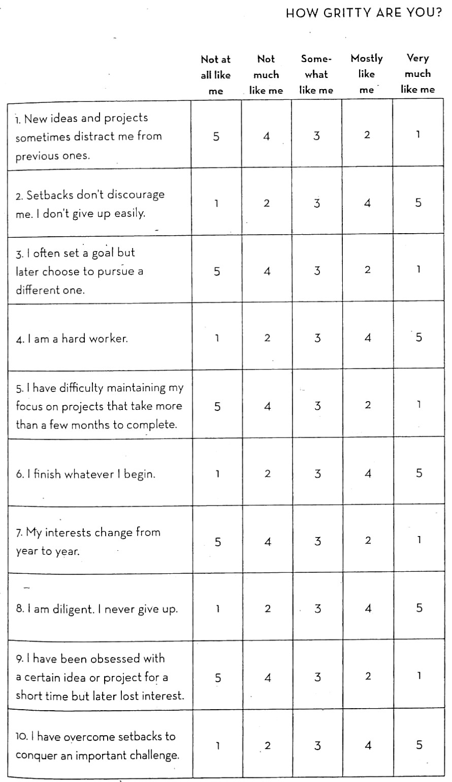

## Appendix D

**Interview Planning Worksheet**

|  |  |  |  |
| --- | --- | --- | --- |
| **SKILL** | **Where Acquired** | **Illustration/Anecdote** | **How it Might Apply** |
|  |  |  |  |
|  |  |  |  |
|  |  |  |  |
|  |  |  |  |
|  |  |  |  |